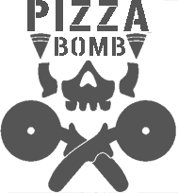Pizza Bomb

Figure 1 :Logo

Retrospective

**Table Of Contents**

1 Introduction 1

2 Initial Planning 1

2.1 Art Direction 1

2.1.1 Concepting 1

2.1.2 Moodboard 1

2.1.3 Color Palette 2

2.2 Blockout 2

3 Asset Creation 3

3.1 Overview 3

3.2 Atlas Based Assets 4

3.2.1 Wallkit 4

3.2.2 Furniture 5

3.2.3 Cleaning 6

3.2.4 Floor 6

3.2.5 Wrestling 7

3.3 Hand Textured Assets 8

3.3.1 Overview 8

3.3.2 Food 8

3.3.3 Additional Assets 9

4 Material Setup in Unreal 9

5 Lighting Color Grading & PBR Adjustments 11

6 Reflection 12

7 Conclusion 13

8 Bibliography 14

8.1 Image References 14

8.2 Usage Of Large Language Models 14

**List Of Figures**

Figure 1 :Logo 1

Figure 2: Color Palette 2

Figure 3: Blockout 3

Figure 4: Curve-Driven Workflow In Blender 4

Figure 5: Wall Kit 5

Figure 6: Furniture Kit 5

Figure 7: Cleaning Props 6

Figure 8: Floor Texture 7

Figure 9: Wrestling Assets 7

Figure 10: Food Props 8

Figure 11: Additional Handpainted Props 9

Figure 12: Master Material 10

Figure 13: Material Function For In Engine Adjustments 10

Figure 14: Final Result 12

# Introduction

The project involved to create a top-down environment in Unreal Engine 5.6. The goal was to create a complete interior scene while staying in the technical constraints for mobile platforms. That meant the level had to adhere to a polygon limit of 300,000 and maximum texture resolution of 1024x1024 per texture. The module was mainly focusing on understanding the concepts of environment art and getting familiar with each step of the process of creating a playable level.

From the start, I set a few clear goals for myself. I wanted to get a stronger grasp of the entire environment art pipeline and learn how to plan, organize, and build a full scene on my own. Along the way, the focus was on improving my texturing, lighting, and composition skills, making sure every asset met industry standards for both performance and clarity.

This retrospective will first describe the planning and conceptual stages, then go over outlining the development of the project’s visual and technical direction. Furthermore, it will then examine the production process, including asset creation, material setup, and lighting. Finally, it will give an evaluation of the project’s results and end with an overview of how the experience will shape future practices.

# Initial Planning

## Art Direction

### Concepting

The workflow began with a conceptual phase, where the theme, and atmosphere of the environment were defined. The idea of combining a pizzeria with a wrestling ring presented both artistic and design challenges, requiring merging two very distinct aesthetics into a single coherent visual style. The goal was to make the space feel lively and authentic while maintaining a readable look suitable for a top-down mobile environment.

### Moodboard

A moodboard was assembled from various references, of classic American restaurants or smaller wrestling venues and fighting events in general. The references were selected not just for visual similarity as well as for the way they communicated atmosphere. Each image served as a guide for surface treatment, color tone, and prop design.

### Color Palette

The color palette was established to maintain visual cohesion and readability. It combined warm reds and yellows typical of diners. I added contrasting purples and greens inspired by wrestling arenas. The intent was to replace harsh blacks and whites with less contrasting tones to ensure a softer appearance. 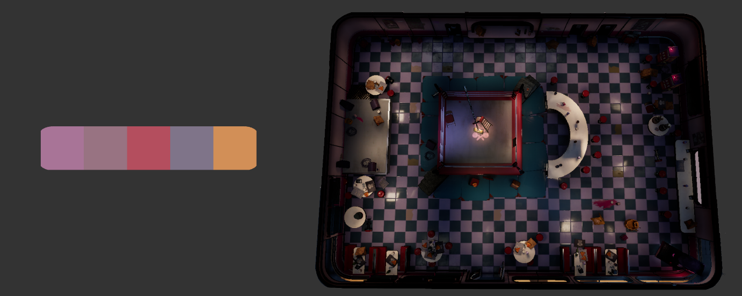

Figure 2: Color Palette

## Blockout

For the blockout stage, I chose to work directly in Unreal Engine. This allowed to quickly blockout the planned composition and scale without being distracted by detailed modeling. Using mannequins as stand-ins for people helped visualizing proportions. I also implemented a navigation mesh early on to ensure the space was functionally navigable before committing to detailed models.

Working directly in Unreal proved highly effective for identifying compositional and layouting issues early on. The process aligned with industry workflows where early testing prevents later design problems. The blockout established a strong foundation for subsequent asset placement.

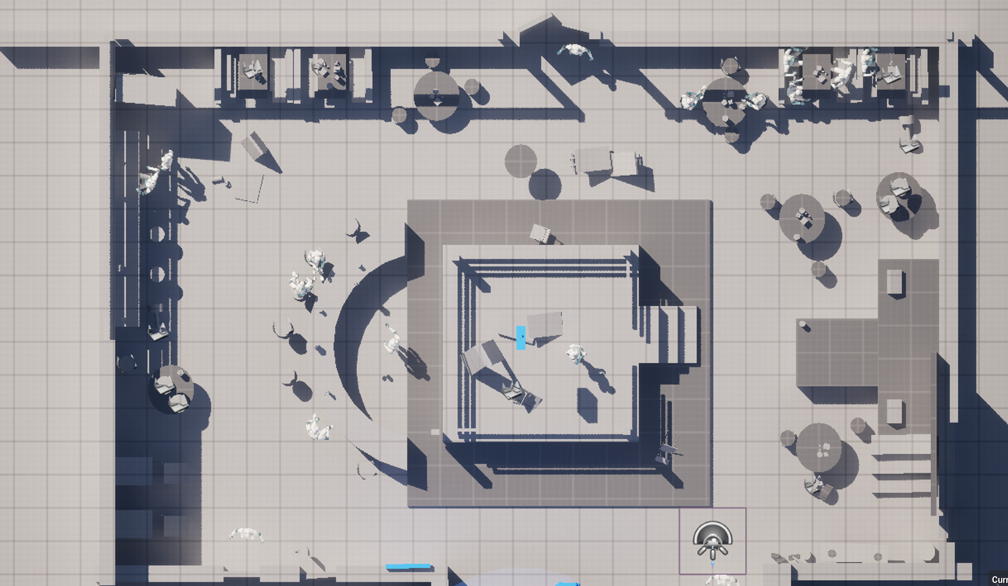

Figure 3: Blockout

# Asset Creation

## Overview

The environment was constructed from several modular asset sets: a wall kit, flooring, furniture and food props, cleaning props, a wrestling kit, outdoor assets, and a set of unique hand-painted props. Where possible, texture atlases and trim sheets were used to reduce texture memory, maintain a consistent material language, and speed up iteration. This approach reflects standard industry practice for real-time production, where modularity and reuse balance visual quality with performance requirements.

## Atlas Based Assets

### Walls

A curve-driven workflow in Blender was adopted for the wall kit to ensure consistent profiles across straight and curved runs. A single wall cross section was defined and instanced along curve splines to generate geometry with uniform thickness. Window and inset modules were created using separate curves to snap into host walls using the same method.

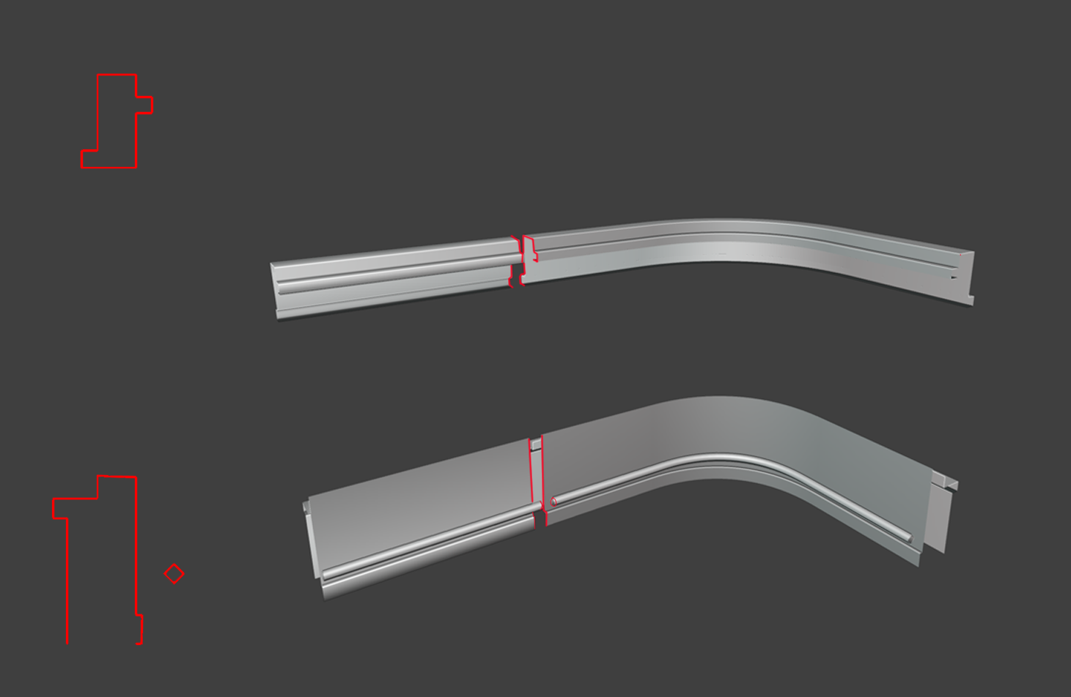

Figure 4: Curve-Driven Workflow In Blender

This method sped up iteration because global adjustments to the wall shape could be made by editing the base curve. However, when testing, a light baking artifact caused by seams between many small modular pieces was observed. Pre-merging contiguous sections in Blender before importing into Unreal resolved these artifacts while retaining sufficient modularity for level layout changes. The trade-off was a small increase in workflow complexity at export time in exchange for working light baking.

This adjustment demonstrated the importance of testing and problem-solving in a-standard workflow, where technical and artistic requirements often develop in parallel. Overall, the curve system proved effective for maintaining proportion, while the pre-merging the meshes ensured robustness for baked lighting requirements.

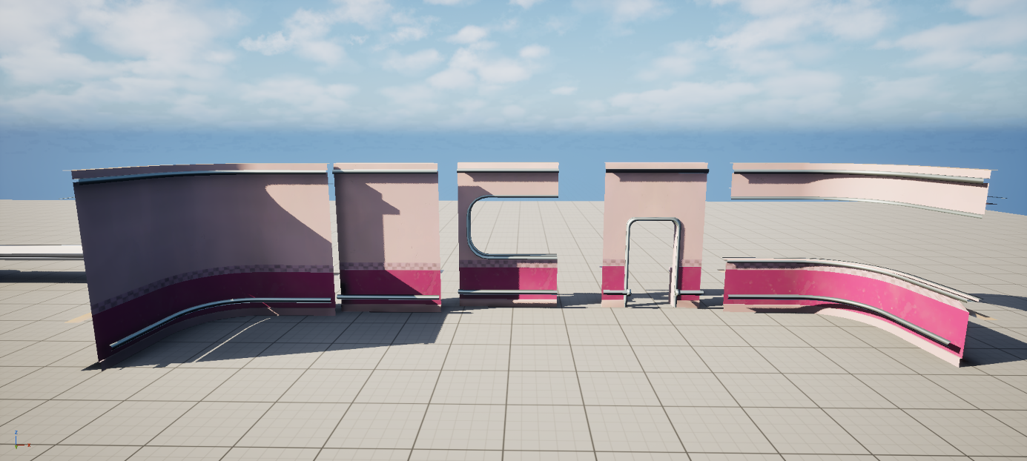

Figure 5: Wall Kit

### Furniture

The furniture acted as one of the main visual anchors of the interior. It established the atmosphere of a classic American diner. Rounded metal edges, polished surfaces, and red leather textures reinforced the retro aesthetic.

A shared trim sheet was used across most furniture assets. This allowed for quick global adjustments to color and roughness while ensuring visual consistency. Tabletops were intentionally kept simple and neutral to keep props and food assets clearly readable during gameplay.

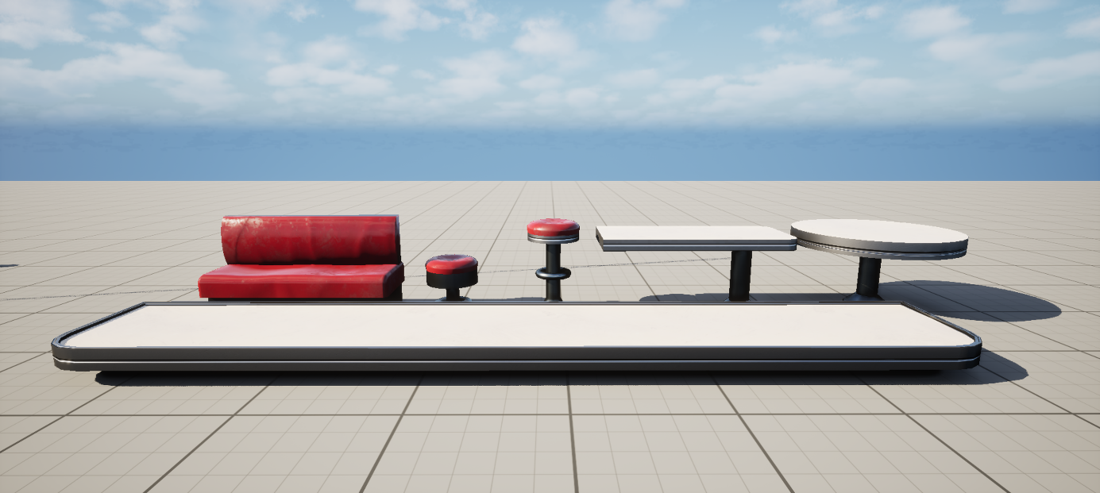

Figure 6: Furniture Kit

The workflow proved efficient and adaptable, reducing texture workload and maintaining cohesion across the environment. Minor problems arose in adjusting surface reflections, but iterative adjustments in Unreal’s material instances helped achieve the desired result.

### Cleaning

The cleaning kit included small yet essential storytelling assets such as mops, buckets, and cloths. Though minor in scale, these items added a sense of everyday activity to the scene. By using materials from a texture atlas, they were produced efficiently while maintaining visual consistency with the surrounding environment.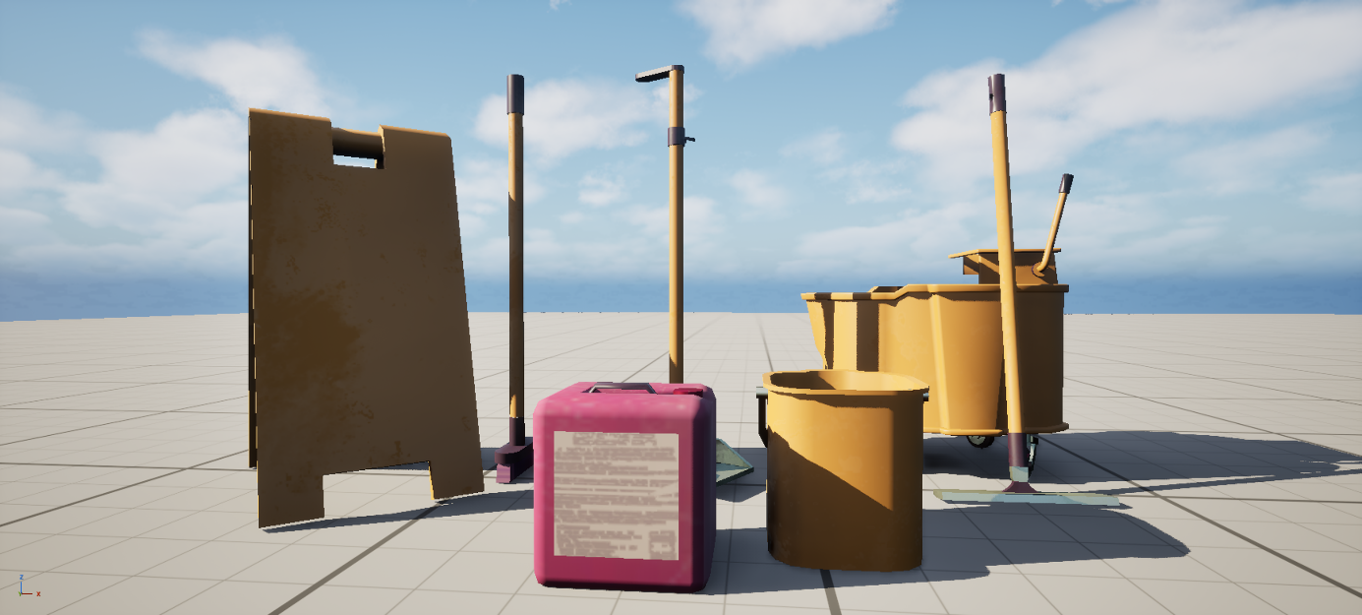

Figure 7: Cleaning Props

### Floor

The flooring was developed in Substance Designer, chosen for its procedural tools and ability to generate seamless materials. A checkered pattern typical of classic American diners was adopted to support the aesthetic of the environment. To reduce visual contrast and maintain focus on key scene elements, the traditional black-and-white palette was replaced with a less contrasty subdued blue and lavendel tones. This reduced visual contrast, allowing the floor to complement the scene rather than compete with key focal elements, ensuring it supported the composition without drawing unnecessary attention.

Given the floor’s prominence in the top-down perspective, it was assigned its own dedicated 1024×1024 texture to maximise texture space and visual clarity. The pattern was carefully designed to avoid recognizable repetitions, ensuring that large, tiled areas remained visually clean.

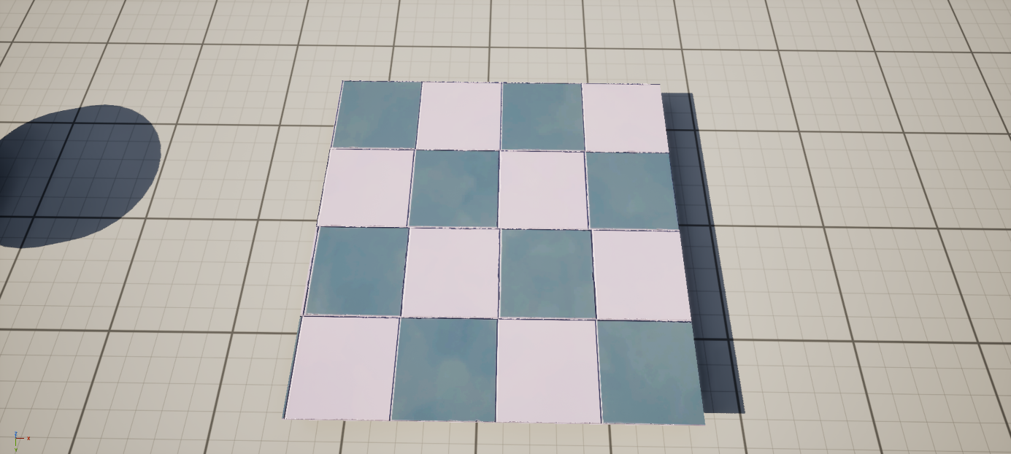

Figure 8: Floor Texture

Subtle decals were later introduced to add localized wear and variation, enhancing depth without affecting performance. The result was a balanced and understated surface that grounded the environment while supporting the overall color harmony.

### Wrestling

The wrestling kit formed the centerpiece of the environment and included the ring, folding chairs, ladder, and chain hanging from the ceiling. The assets achieved the necessary visual variety and focal importance. While the overall readability and balance between materials worked well, the lack of localized wear and minor surface variation slightly limited realism. Introducing decals or subtle normal details could enhance surface richness in future iterations.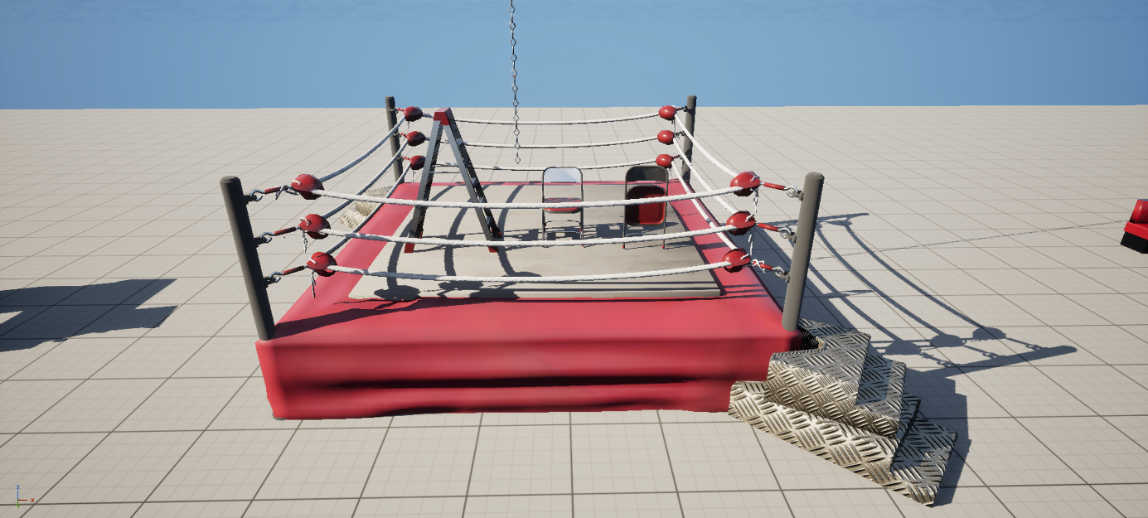

Figure 9: Wrestling Assets

### Outdoor

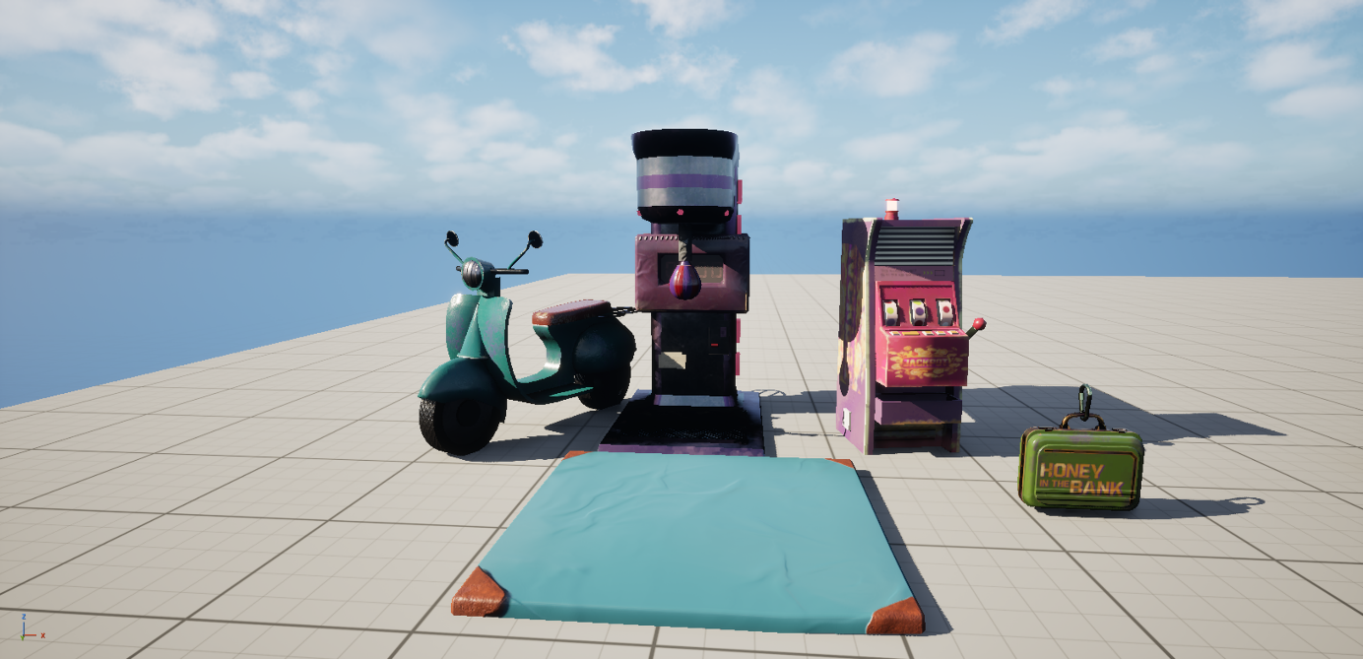

## Hand Textured Assets

### Overview

A small selection of props required unique, hand-painted textures, as their shapes and surface details were too specific to fit efficiently onto shared trim sheets. These included the food props, the central suitcase, the boxing machine, and the slot machines. While the intention throughout production was to minimize individually textured assets, the decision to hand-paint these models proved essential for storytelling and atmosphere. This approach introduced a level of personality and authenticity that could not be achieved with fully modular materials. Although creating these textures increased production time, the added visual distinctiveness and narrative value justified the effort, contributing significantly to the scene’s overall charm and cohesion.

### Food

The food assets were central to establishing the sense of liveliness within the pizzeria, functioning as focal points that communicated the environment’s everyday use. Each prop was hand-painted to achieve a look that remained visually clear from the top-down perspective. Slightly adjusted proportions improved readability without disrupting the overall scale consistency. 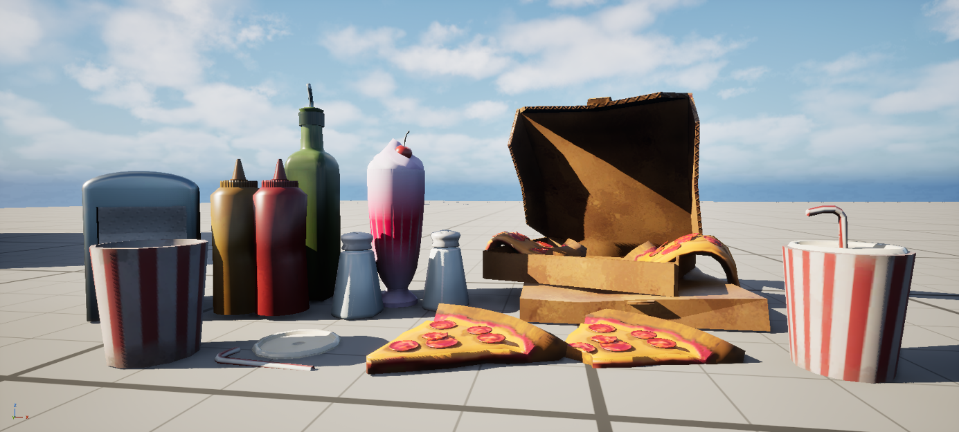

Figure 10: Food Props

This approach required more time than atlas-based workflows but proved worthwhile, as the unique textures and deliberate placement of food props added warmth and narrative depth to the space. The result was an environment that felt more active and believable, illustrating how selective hand-texturing can meaningfully enhance the storytelling quality of a scene.

### Additional Assets

The final set of hand-painted props, such as the Money in the Bank suitcase, the surrounding floor mats, the boxing machine, and the slot machine, acted as visual highlights that broke up the repetition of modular elements. Each asset was textured individually to preserve its unique character, which would have been lost through atlas-based workflows.

This manual approach offered the flexibility to fine-tune color accents per asset and wear, giving these props a more expressive and deliberate finish. Their presence added a layer of eccentricity to the environment, grounding the envornment in a believable context. Despite the extra effort required, the result was a stronger overall composition where these focal elements naturally guided the viewer’s attention and reinforced the narrative tone of the scene.Figure 11: Additional Handpainted Props

# Material Setup in Unreal

Most assets in the scene were built using a single master PBR material in Unreal Engine. Each asset utilized three primary texture maps: Base Color, Normal, and a packed MRA map containing Metallic, Roughness, and Ambient Occlusion information. Ambient Occlusion was only applied to the hand-textured assets, as it provided additional surface depth and variation that could not be achieved through tileable textures alone.

I used a material function to allow quick adjustments in the material like changing roughness, normal or albedo values in a material instance quickly to test different visual looks or fix small issues right in Unreal.

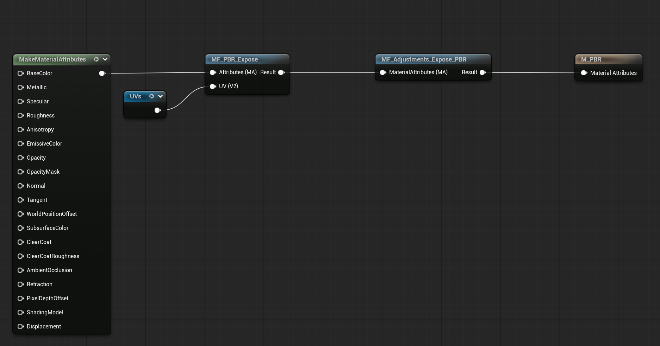

Figure 12: Master Material

A custom material function was implemented to allow quick and flexible adjustments within material instances. This setup made it possible to modify parameters such as roughness, normal intensity, or albedo values directly in Unreal without returning to external texturing software. This workflow improved iteration speed, especially during the lighting and polishing stages, where subtle changes in material response could have a big visual impact.

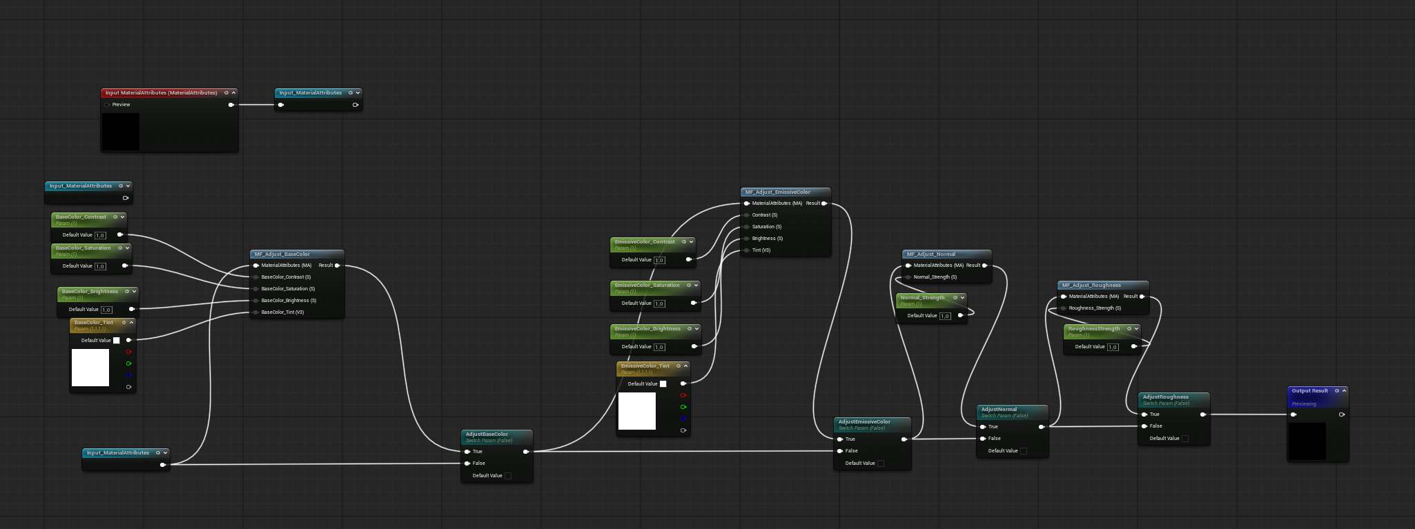

Figure 13: Material Function For In Engine Adjustments

# Lighting Color Grading & PBR Adjustments

Lighting was among the most technically demanding aspects of the project. Previous experience with interior lighting was limited to Unity, which made Unreal Engine’s light baking workflow and mesh preparation requirements a new area to master. The process involved extensive experimentation over the course of about a week before achieving results that aligned with the intended visual goals.

In addition to the interior, the project also required lighting both the restaurant’s indoor space and the exterior frontage. This turned out to be trickier than expected, mainly because Unreal Engine’s lighting channel system (normally useful for isolating which lights affect which meshes) doesn’t function with baked lighting. That limitation made it impossible to light the two areas separately. On top of that, I had no post-process volume, which meant I couldn’t fine-tune exposure or color grading between the interior and exterior. Together, these restrictions made it difficult to give each space its own lighting mood. To work around this, I decided to shift the overall time of day toward a late-evening setting. This not only simplified the exterior lighting but also tied the whole scene together more naturally. Looking back, I realized it would’ve helped to test such technical limits earlier in the planning stage—doing so would have saved time and allowed for a smoother, more deliberate approach to scene composition

Initial lighting tests employed a directional light to act as sunlight. However, this produced overly harsh shadows that created high-contrast areas. After some feedback it turned out that it diminished the visibility of key focal points such as the wrestling ring. To address this issue, the directional light was replaced with several rectangular lights placed outside the windows to simulate indirect sunlight. This solution softened the shadows and improved the overall balance of the scene.

Throughout this process, attention was given to ensure physically accurate albedo values for all materials. Reference data from *physicallybased.info (Physically Based, 2025))* was used to verify the brightness of materials against real-world PBR standards. This comparison revealed that several materials (particularly metallic surfaces) were too dark for the lighting setup. Adjusting their albedo values improved the lighting by a lot.

The color palette and material cohesion also required significant refinement. Some materials appeared mismatched under various lighting conditions, and adjustments to hue, roughness, and brightness had to be made to ensure a consistent visual language. These refinements helped maintain readability and harmony from a top-down perspective.

In retrospect, lighting planning would have been more effective if integrated into the early blockout stage. Establishing preliminary light sources at that point would have allowed materials and assets to be evaluated under near-final lighting conditions. This would have reduced the need for major revisions later in production. Future workflows should incorporate lighting design earlier to facilitate more efficient iteration and stronger visual outcomes.

The time demands of lighting were also underestimated. Given the substantial impact of lighting on the overall atmosphere and presentation, a more focused balance between asset creation and lighting refinement would be beneficial in future projects.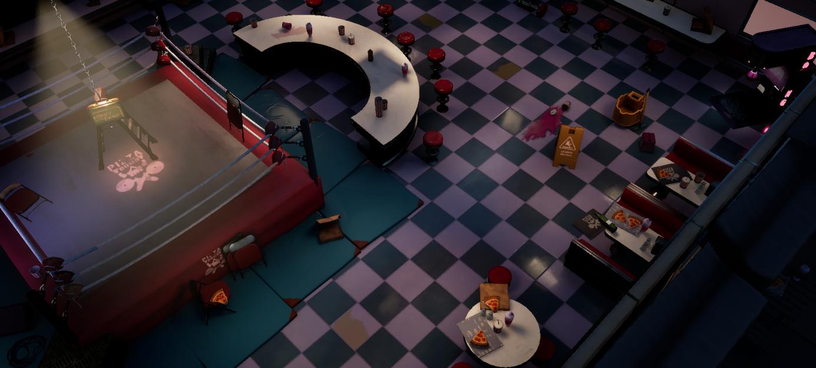

Figure 14: Final Result

When compared to professional environment art seen in mobile and stylized titles such as *Overcooked!* or *WWE 2K Battlegrounds*, the project achieves comparable clarity in color design and modular efficiency but falls short in surface richness and lighting nuance. Professional environments typically feature more dynamic light-material interaction and fine-tuned wear that guide player focus and enhance believability. Achieving this standard would require more advanced decal use, secondary lighting passes, and a stronger balance between baked and dynamic lighting. Nonetheless, the production pipeline and optimization principles closely mirror established industry workflows for modular, mobile-targeted environments.

# Reflection

Reflecting on the process, the project highlighted the importance of structured iteration and early technical testing. Integrating lighting experiments and material checks during the blockout stage would have prevented some of the late-stage revisions and improved overall efficiency. I also learned that allocating time for visual polish must be planned as deliberately as modeling or texturing, as subtle adjustments in color balance and roughness can transform the final presentation. From a professional standpoint, I maintained ethical standards by creating all models and textures from scratch, but future collaborative projects will require closer attention to shared asset licensing and data management. Ultimately, the experience deepened my understanding of how creative storytelling, optimization, and technical execution interconnect-insight that will directly shape my workflow and decision-making in future environment production.

# Conclusion

The completion of this project provided valuable insight into the full production pipeline of environment creation, from concept development and blockout to modeling, texturing, lighting, and final presentation. Working under technical limitations such as polygon and texture budgets encouraged an efficient, industry-relevant workflow focused on modularity, reusability, and optimization. Through the process, a deeper understanding was developed of how technical and artistic decisions interconnect to form a coherent visual result.

Particular growth was achieved in areas such as lighting and material setup, where experimentation and iteration were essential to achieving physically lighting reponses. The project also strengthened the understanding of environment storytelling, demonstrating how prop placement, color design, and lighting collectively shape the atmosphere and convey narrative meaning.

Overall, the project successfully met its objectives by producing a cohesive and believable stylized environment optimized for mobile platforms while reflecting professional workflows and creative decision-making. The experience reinforced the importance of planning, iteration, and adaptability. These are all skills that will inform future projects and contribute to more efficient and artistically grounded production practices.

# Bibliography

## Text References

Palmqvist, A. (2025) *Physically Based - The PBR Values Database* Available at: https://physicallybased.info/.

## Image References

Figure 1: Unknown. (n.d.) *TonyPizzaGuy Pizza Club T-Shirt*. Amazon. Available at: https://www.amazon.com/TonyPizzaGuy-Pizza-Club/dp/B07K2SDSGN

## Usage Of Large Language Models

I acknowledge the use of ChatGPT (GPT-5, https://chat.openai.com/) to proofread the spelling, grammar, and punctuation in my retrospective.